Social Media Footprint Analysis Report
  - Author: Esther Happiness Ogbudu
  - Date: 14th July 2026

Overview
This project demonstrates the use of Open-Source Intelligence (OSINT) techniques to analyse the publicly available social media footprint of an authorized account.
The assessment identifies publicly accessible information, evaluates potential security and privacy risks, and provides recommendations to reduce unnecessary exposure.

Objectives
The objectives of this assessment were to:
- Identify publicly accessible social media profiles.
- Determine what information can be collected using OSINT.
- Demonstrate ethical OSINT investigation techniques.
- Produce a professional security assessment report.

Commands used
- Sudo apt update && sudo apt install sherlock -y -> used Kali’s built in package to install sherlock
- sudo apt install && sudo apt install -y libcairo2-dev pkg-config python3-dev build-essential pipx -> to download maigret first download the system prerequisites.
- pipx ensurepath -> inject path configuration
- pipx install maigret -> install maigret globally
- maigret {name} - -html - -pdf -> to generate a full html/pdf dossier

Target
Personal accounts owned by the researcher.
Tools Used
Tool | Purpose
Sherlock | Username enumeration
Maigret | Cross-platform username search
Google Dorks | Public search
Kali Linux | Virtual machine
Screenshots
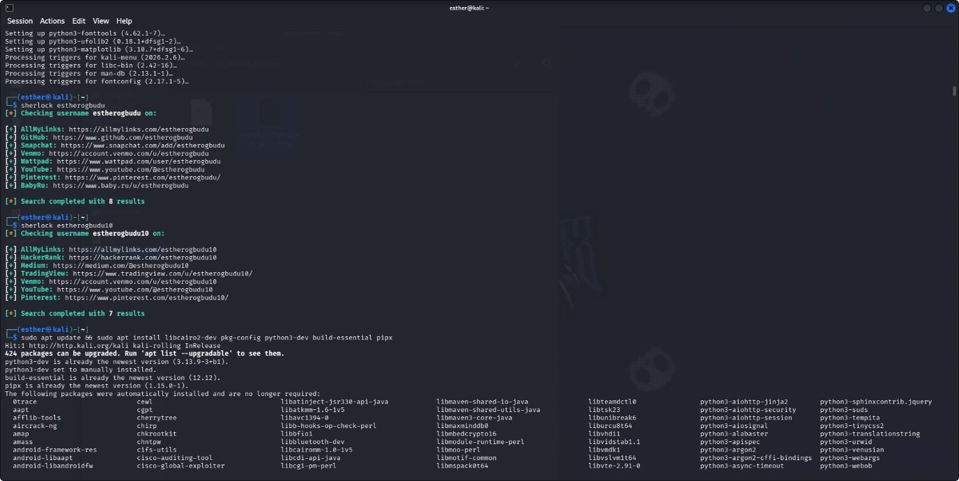
The tool checked each handle across its site list and returned confirmed hits.

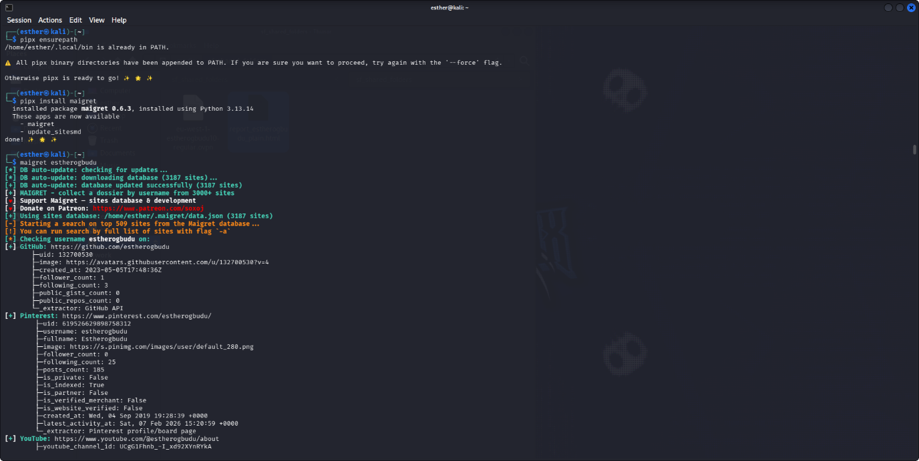
This captures the Maigret installation via pipx. Maigret auto-updates its site database (3,187 sites) before searching the top 500.
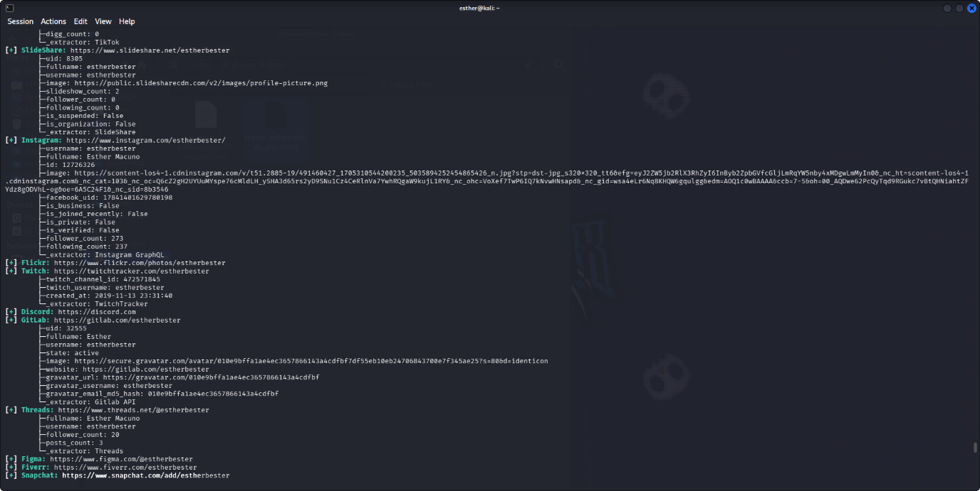
A continuation of the Maigret scan output, showing further confirmed accounts.
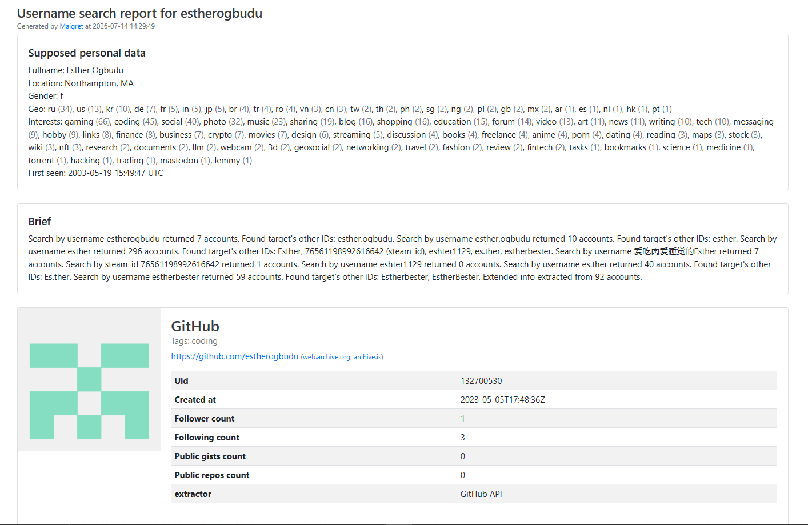
This is the rendered report Maigret generates (--html --pdf flags), consolidating everything into a single "dossier."
Limitations
This assessment only included publicly available information and did not involve:
- Password attacks
- Private accounts
- Unauthorized access
- Network scanning
- Social engineering
Results represent information available at the time of the assessment.

11. Conclusion
The assessment successfully identified publicly accessible information across multiple platforms. While most information was intentionally shared for professional networking, several opportunities were identified to improve privacy and reduce unnecessary exposure.
The project demonstrates practical OSINT techniques, ethical investigation practices, and the ability to communicate findings through a structured security report.

